**What you’ll learn:**

* Recognize how internal service impacts external service
* Determine factors that create customer value
* Identify needs of internal & external customers
* Develop strategies to gain an emotional connection with your customer
* Define internal & external customers
* Link service to outcome
* Develop strategies to support the modern-day customer – inclusive of the ‘millennial’ customer

**Who this course is for:**

* Anyone looking to improve the experience of their customers
* Anyone with an interest in driving a strong customer focus within their organization
* Anyone looking to develop their organization into an environment that customers want to interact with and develop loyalty to
* Anyone with frontline customer service experience, leadership, or management experience, whether in a junior to middle management level or those who wish to move into a middle/senior management role within a customer-focused organization
* Anyone from a small, medium, or large organization

**How to Understand Your Customer Needs  
The Service Profit Chain**

What impact does internal service quality have on your profit? Everything!  
An internal customer is anyone inside your insurance agency - team members & stakeholders that benefit from services. They are equally, if not more important than the individuals outside of the insurance agency that you serve, also known as your external customers.

The service-profit chain establishes relationships between customer loyalty, employee satisfaction, and productivity – all important elements in driving profit.  
This shows the relationship between focus, outcome, and therefore output.

This concept also demonstrates “What you give is really what you get!”

Let’s take a look at the service profit chain a bit closer to get a better understanding:  
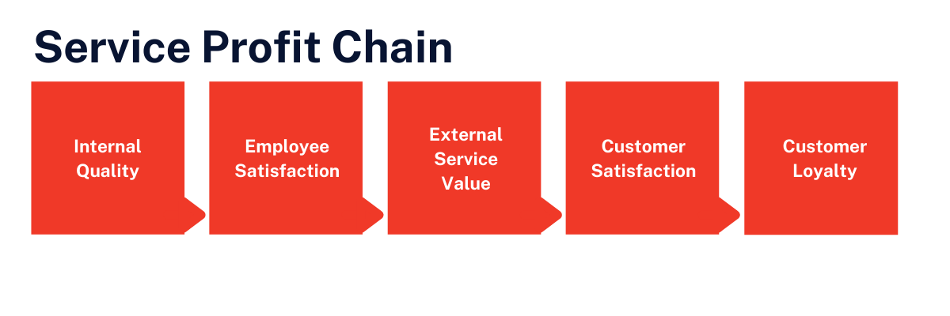

Internal quality is the first stage of the service profit chain. This link in the chain is about driving motivation in your team.

Think about your insurance agency.

What kind of workplace design are you providing?  
How have you designed their job? Sales goals & requirements? Profit centers?  
How are you helping them grow professionally with mentoring, coaching, and other resources?  
Are you recognizing them and rewarding them frequently?

So, what are some things we can do to drive internal quality once we have the design right?

Start with clear limits & expectations.  
Make sure your team knows the objective of your insurance agency and their roles in achieving them, all the way from the get-go.  
Provide high-quality training. The minute your teams stop learning – they’re going backward.  
Give positive feedback, and celebrate team successes – focus on what is working, not just the mistakes!  
Give your team the freedom to provide the results your customers are asking for!

All these items contribute to the next link in the chain: employee satisfaction.

Consider a team who knows their goals and wants to achieve them.  
It’s like dropping a pebble in a pond; the ripple effect will be obvious  
We can really see how employee selection plays a role here.  
Creating motivation means considering both job context & job content.

Job context will be related to your external conditions: commissions or wages, how you create your sales goals for profit centers, and benefits.  
Context merely prevents demotivation.

Obviously, if there are unsatisfactory physical conditions – it would prevent team members from staying with you long term.  
But the determining factor for motivation & team satisfaction is job content.

When we connect and contribute to something meaningful, it gives us a high degree of motivation.  
Within several organizations, I’ve worked to help develop a customer service model – we focused on shifting their team’s mindset of what it is they do.  
Instead of looking at the organization as an insurance sales agency and the policies they sell – just look at sales goals. We looked at how meaningful the policies were to the people they helped.  
The customer service model we created helped their team see that they were impacting lives by helping lower prescription medication costs or protecting someone’s savings account with a hospital indemnity plan.  
  
This turned the agents' perception and motivation on sales goals into something meaningful and something they cared about doing. They felt there was value in their work!  
  
It’s also important to acknowledge employees on wins! And empower your teams to make decisions independently and trust they are capable of making those decisions, based on the amount of training and real-time coaching and mentoring you’ve provided.

Do you think you got the content right but are still trying to figure out what’s not working?  
The next time your team doesn’t seem satisfied, or you can’t see productivity & retention, ask yourself – why is my team not satisfied? What is the quality of service they are provided? Are our efforts balanced? What do we measure?

What you measure is what you focus on, so measure satisfaction in your team; they’re the ones driving your business. Emphasize the importance of your team's needs when setting up success measures & strategies.  
Going back to the lives impacted model – don’t measure the number of sales, have them tally the number of lives impacted. You can also create a point system around how different cross-sales opportunities can contribute to a bigger impact – have fun with it and get your team involved.

How does all of this drive external service value?

Frankly, you can’t achieve customer satisfaction without providing them value; value refers to the importance, worth, or usefulness of something.  
What people see as value is very personal and can vary from person to person. It’s important to remember this when it comes to strict sales guidelines and models you implement.

Think of it this way, if a customer has a choice of two products that are exactly the same and cost almost the same amount – what’s going to make the difference when they decide to buy?  
There are some factors that help us to understand how we make these decisions.

As we go through these, think about them for yourself.  
You might find you weigh more heavily on one versus another or that it depends at different times.  
That’s good because that’s exactly how your customers feel as well.

First of all, what’s the result we’re trying to achieve?  
What’s our primary need?  
For example, ___________________________________________________________.

It shows the need to truly understand what outcome or outcomes your customer is looking for when accessing their perception of value.  
Your team has an impact on this, depending on how much they care about what the customer is trying to achieve.  
Care for them, and they’ll care for their customers.

One of the other considerations is the process to achieve our result, or more specifically – what’s the best way to get there?  
As busy people, we want the easiest and best way to get to our goal.  
Your team can make a big impact on how the external customer feels about the process.  
If they are frustrated or have too many barriers, then this will be felt outwardly.  
We will, of course, also consider the price of the product we want or need.  
It's not always about the cheapest.  
But it is about being competitive & in line with the value of what we are receiving in return.

Your team can influence the customer’s perception of whether the price is too high or too low based on their own interpretations.  
So help them to understand why the price is right.  
Lastly, when deciding where to get something from, we consider our effort to get there.  
If the option was easy versus hard – which would you choose?  
In most cases, it would depend on what you’re paying for – effort is all about how much the customer has put in the experience to get a delivery of the service.  
If you do more, you expect to pay less – and vice versa.

So we’ve looked at internal quality, which has driven our employee satisfaction; this has then led to the delivery of external value to our customers.

Let’s now move on to customer satisfaction.

When you’ve designed and delivered your service to meet the needs of the customer, you’ll have customer satisfaction.  
When they see the value in your products & services, you’ll have customer satisfaction  
When you ask a person about a service that they experienced that was truly satisfying, it’s never just about the facts.  
No one ever only mentions the product features in the price; there is always a human element in satisfaction.

Now we can really see how happy teams lead to happy customers.  
And finally, the last element in our chain – customer loyalty. Customer loyalty propels you to growth & profit. Loyal customers spread the word to friends and family members about the satisfaction they experienced. Loyalty creates retention of customers – related sales, referrals, and greater funds for growth & development.

So, you want profit? Focus on the service profit chain and not only can you achieve it, but you can make it sustainable through satisfied & loyal teams & customers.

**The Relationship Between Employee & Customer Satisfaction**

Let’s take a look at the relationship between employee & customer satisfaction and how it impacts customer experience.

To transform the relationship between your agency & customers – you need to exceed expectations & create goodwill.  
Going the extra mile & empowering your employees to do this on behalf of your agency changes everything.

Perceptions alter, reputations are improved, and social media becomes less feed frenzy and more about free advertising and hearty testimonials.

It might have been easier to get away with poor customer service in the pre-digital age, there weren’t many channels for grievances to be aired. But now social has changed everything.

So who’s responsibility is to exceed customer expectations?  
The answer is simple. It’s everyone’s responsibility.

Your attitude has as much power to affect customers as the employee stuck on the line with a frustrated customer. If employees are not valued, their lack of value will consciously or unconsciously will drive their interactions with customers.  
It needs to be an everyone on board exercise and not about sales targets.

Remember, the customer experience is at the forefront of why we do things.  
That is our business. The relationship business. The people business.  
We need to do whatever it takes to make it an experience they remember.

To help us exceed our customer expectations, it’s worth looking at the relationship between our internal and external customers.

**What is the difference and why are they important?**  
Internal customers work in your organization at all levels and across departments, for example, CEO or agency principal, managers, supervisors, operations, or HR.  
External customers are outside of your organization who buy and experience the product or service.  
If both our internal & external customers are communicating with one another and feel supported, a better relationship transpires.  
  
See your agents and operations team as customers first, and show them what quality customer service looks like. The goodwill fostered in internal customers will inspire interactions with external customers.  
It makes for a better result all around.

Take a moment to reflect:  
How often do you think about your customer?  
Do you consider yourself an internal customer?  
Do you even know who they are?

Internal customers are team members in your organization who contribute to the service provided to the external customer.  
This means that their contribution can make or break you.  
  
Let’s look at that in a scenario, let’s say your sales have been steadily declining for awhile now.  
The first question is obvious: why?

Customers have been left feeling unsatisfied with the service lately. We know it because we’ve received several complaints.  
So why are the customers complaining?  
Good question.

The team hasn’t been managing expectations.  
Customers are feeling like they’re paying too much for a policy but receiving too little customer service or benefit from the plan.

Why is the team not managing the customers’ expectations?

Well, they’re just not motivated by the product at the moment.  
They don’t seem to believe in it, and they’re just going through the motions – they’re selling based on price purely to meet their quota.  
  
Why isn’t the team motivated?  
I’m glad you asked! The sales goals have changed recently, and the team doesn’t understand why. They were happy and comfortable with the way it was, and they don’t see benefits in the new goals based on rate increases and other disruptions in the market.

They feel under-resourced to obtain these incentives, and under-trained in the market disruptions and products now available.

Last question, then, why do they not have what they need?

As leaders, we’ve assumed the team would just be able to roll out the change without needing to do too much.

There was a lot of time, money and effort putting together rate increase notices, and other care packages for the customer, but not enough focus on the team’s needs as well.

So how did we arrive at that very specific reason behind why sales were declining?

Well, we asked why – not just once.. but five times which allowed us to break the situation down from what was the symptom, sales were declining to the real cause. Us.

Now that you have multiple strategies to not just fix the situation, but avoid it again in the future, focusing on your internal customer means checking in to see if they have everything they need.

If your external customer’s needs aren’t being met, let’s first assume that your team is trying to do a good job, not a bad one, and work back from there.

In most cases, you’ll find some barrier or blockage getting in the way, and sometimes it might even be the result of you.

When focusing on our team like this, do we always need to ask why five times?  
Not necessarily. You ask why as many, or as few times as you need, to get your real cause and allow you to figure out the support them at a higher level.  
Why?  
Because it works!

**Identifying External Customer Needs**

As customers, there are some basic needs we want met.

First, we want to make our customers feel like we’re a team and that we’re in this together. Make them feel like you’re all on the same side! It’s easy to do this when you focus on a few critical components:

1. Focus on understanding.
   1. Empathy over judgment wins hands down.
   2. It’s never nice to feel judged by others. You might know more, be an expert or qualified, but that doesn’t give you freedom to put others down.
   3. Use your knowledge to educate and create an understanding, not criticize, or create confusion.
2. Focus on fairness.
   1. Have you ever been waiting in an imaginary line where you know who you are standing before and after, but you’re not sure the sales assistant does?  
      You know, that feeling of anxiety worrying someone’s to be able to cut in front of you?  
      We’ve all felt it, and it’s not nice.
   2. No one wants to feel second best.
   3. So, use strategies and processes to create equality in your service experience.
3. Focus on control.
   1. We like to be able to have an impact over the way things turn out, we don’t generally like when we must follow someone else’s rules.
   2. Guide your customer through their journey, but don’t tell them what to do.
4. Focus on options.
   1. “If I can’t have this, can I have something else?”
   2. Offering alternatives and different avenues is better than a flat out ‘no’
   3. Think about your language, and how you can turn a negative into a positive, so your customer doesn’t feel like they don’t have a choice.
5. And finally, focus on information.
   1. The more educated and informed we are, the better.
   2. The more educated you are, the better!
   3. These days, with information everywhere, it’s just as likely that your customer already feels like they know a lot about what they want.
   4. Don’t preach to the choir, determine their level knowledge, and provide only what’s necessary, not everything you know.

You don’t always have to exceed expectations, in most cases, it’s enough just to meet them, whether you’re aiming high or trying to just get it right, good communication can be the key!

How do people know things if we don’t tell them?  
Sometimes it can be as simple as just talking openly and creating understanding on both sides.  
That makes all the difference.

So pay attention, be responsive, and you’ll reap the rewards!

**Why Employee Satisfaction is Key to Customer Service**

A new study of the University of Missouri has found that companies that attend to employee satisfaction can improve internal morale, prevent turnover, and enhance customer satisfaction including repurchasing intentions.

Christopher Groening, from Kent State University, who is Chair at the Department of Marketing & Entrepreneurship, says the link between satisfaction & loyalty is almost twice as strong when you have high employee satisfaction, compared to when they’re not satisfied with their jobs.

Groening recommends the following to improve the employee satisfaction based on answers from employee survey questions:  
  
1. Train and empower employees so they have the tools to make decisions that are beneficial for your insurance agency and each individual customer; instead of following a simple flowchart and possibly upsetting a customer with the outcome.

2. Hire managers who serve as examples and can be mentors with employees; if a company policy is established it should be honored by managers as well as employees.  
Managers should help employees know what is expected in order to advance in their company.

3. Create good working atmospheres, offer incentives and intangible benefits, such as flexible working hours, if possible.

Groening says the relationship among the CEO, the employees, and the customers are all linked.  
It's important for CEOs to know they can have a large impact on customer service without ever talking to a customer or without implementing a customer service policy.

A quote from mark Cuban:  
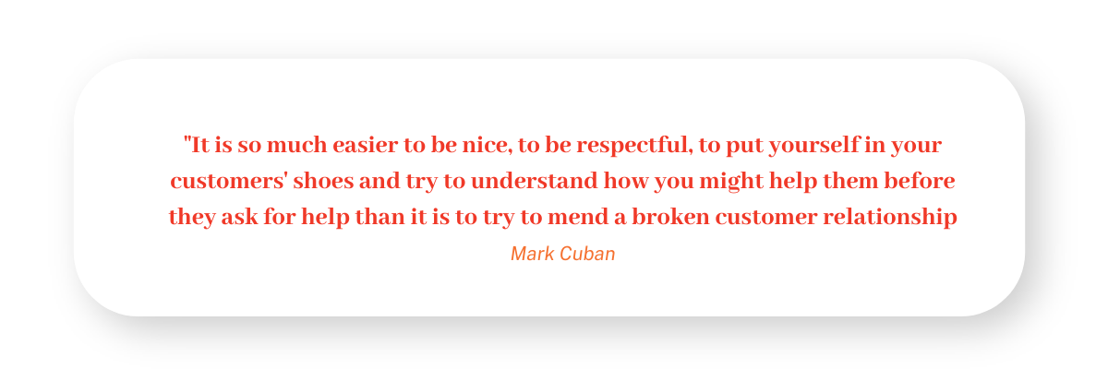

Identifying the Modern Day Customer

The expectation of service is everchanging as the world continues to evolve. If we look throughout history it becomes apparent that we were extremely limited when we wanted to complain to or ask a question of a business. That is no longer the case! We are connected more than ever before. Check out some of the behaviors of the modern consumer:

Our preferred customer service channels (in order of preference):

* Email
* Mobile Phone
* Landline
* In-person

Where we go to resolve questions before calling someone:

* Company website
* Live Chat
* Social Network
* Mobile App
* None of the above – always call first

When it comes to customer service, how do we rate against each other? Which industries really get our goat?

* Financial Services
* Healthcare
* Telecom
* Retail
* Travel

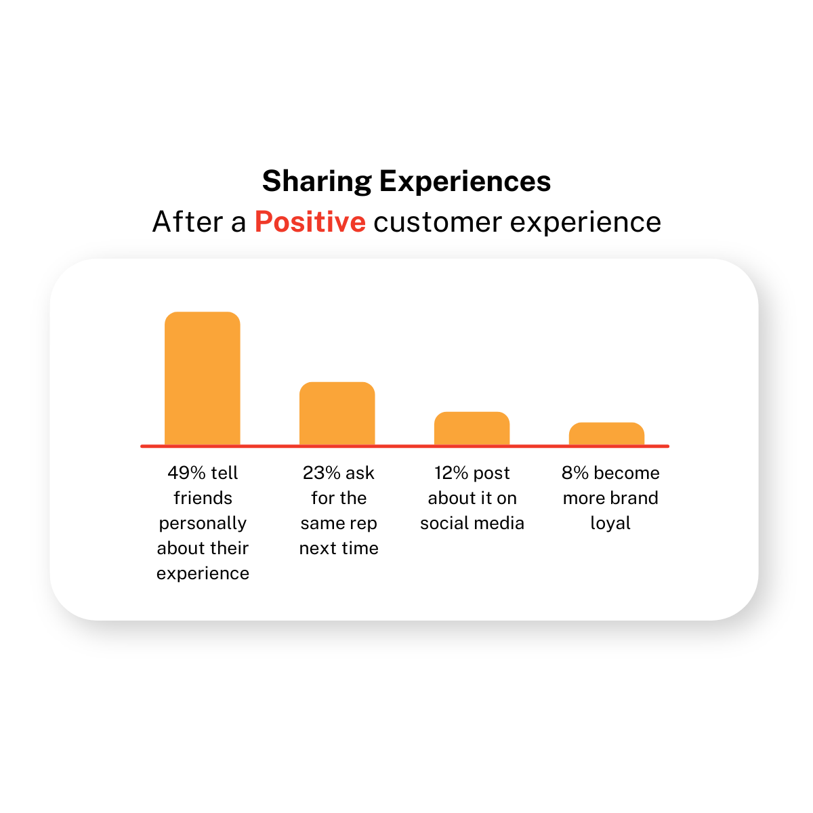

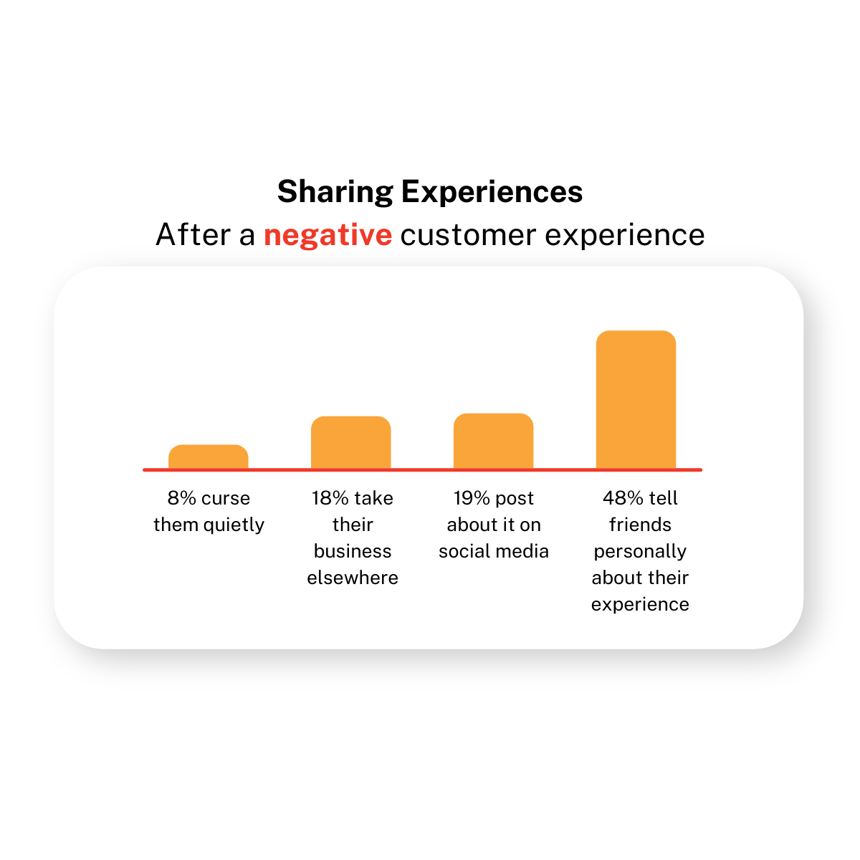

Things have changed with how consumers act and how they are served since the 1970’s verses today.

In the 70’s customers were generally served either face-to-face or in-person. The window of opportunity was very small. The only way a customer was able to complain was through a letter, phone call, or directly in-person.

Today, people are served through multiple different channels. 24/7 support services are commonly available and social media plays a massive role in consumer behavior.

Due to these changes, there has been a 41% increase in out-of-hours calls reported across business. Clients are less likely to check hours of operation and presume that is they are working, then others should be as well. Traditional M-F 9-5 hours are becoming obsolete as consumer behavior continues to evolve.

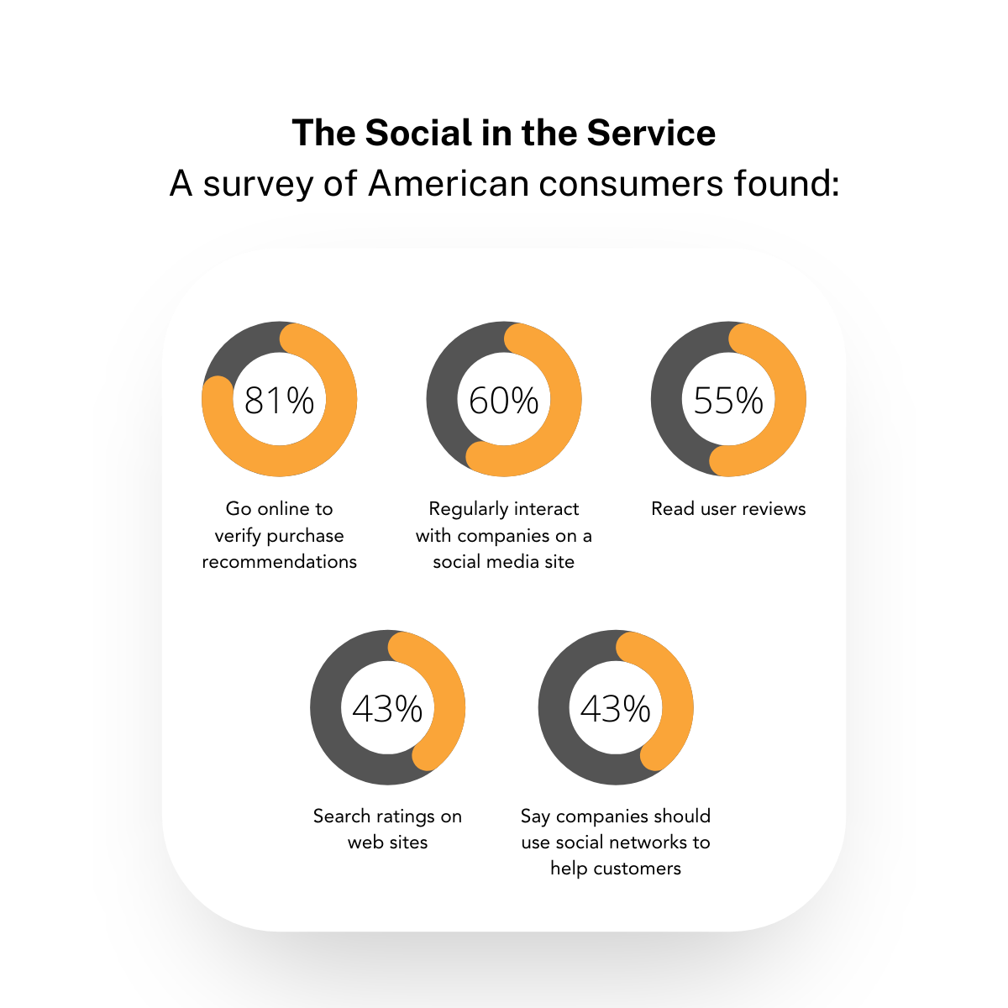

**Strategies for the Modern Day Customer**

As with every other aspect of business, the advancement of technology has increased the complexity of our needs and expectations making it necessary to shift our thinking around what actually keeps our customers with us longer.

Consider the following ideas for your insurance agency:

Look to offer multi-channel continuity.  
Most of us these days start thinking about a product, pop online to check it out, and then start to plan for how we want to buy it from there.

What does this mean for you?

Your customers want and need options and consistency.

It might be anything from running a quick quote, making an inquiry, or how their shopping experience plays out online versus in your brick and mortar store.

Whatever it is, make sure it represents you and gives them the options they’re looking for.

Another aspect to think about is social customer service. Customers will find you wherever your brand has a channel. And if your brand doesn’t operate on their preferred channel, it’s frustrating. These days, it’s about Facebook, Twitter, Instagram, Snapchat and the rest – know your market, and how they want to interact with you.

Making people’s lives easier is a great way to improve retention and increase customer lifetime value.

For example, mobile banking apps free customers from the need to call into branches or use the telephone. It saves them time and thus enhances their lives in a small way. Think about ways you can give you customers access to your insurance agency without having to stop by your brick and mortar location or picking up the phone and leaving a message for you. Give them live chat options, Facebook messenger or other direct message options – or SMS text.

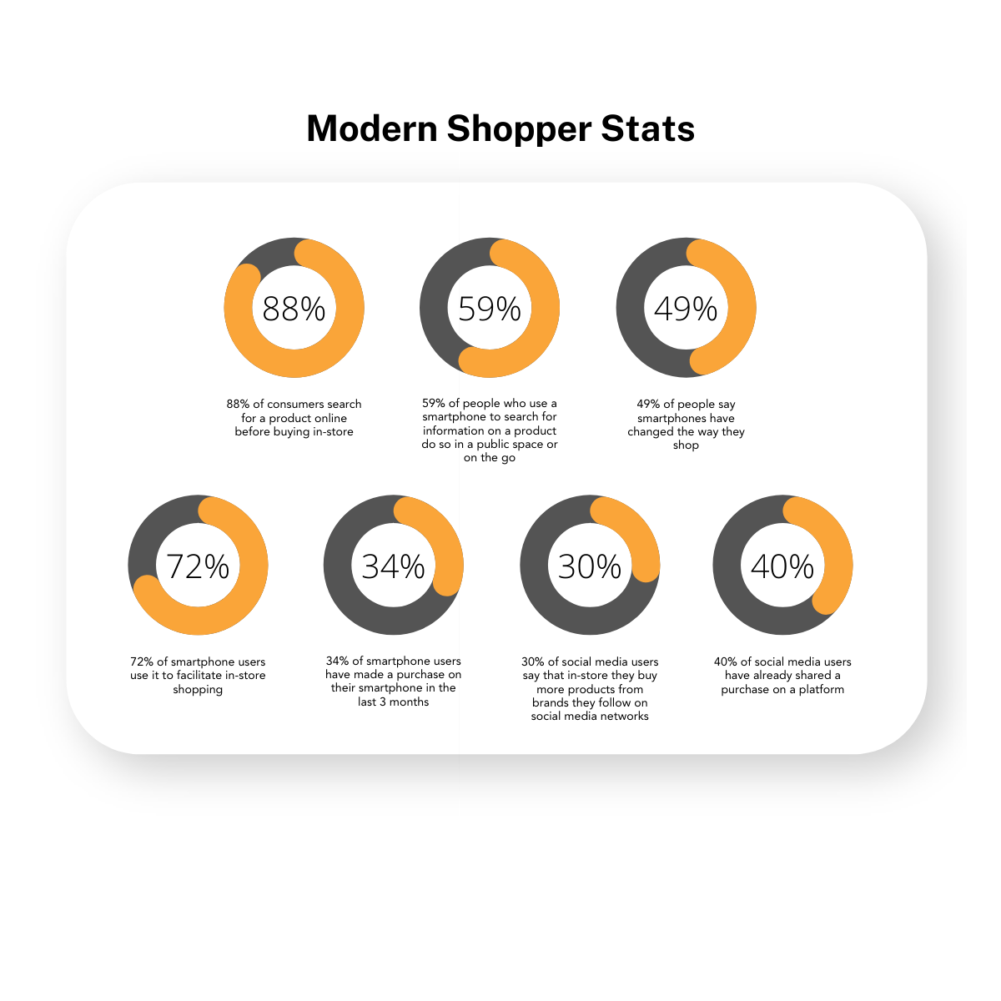

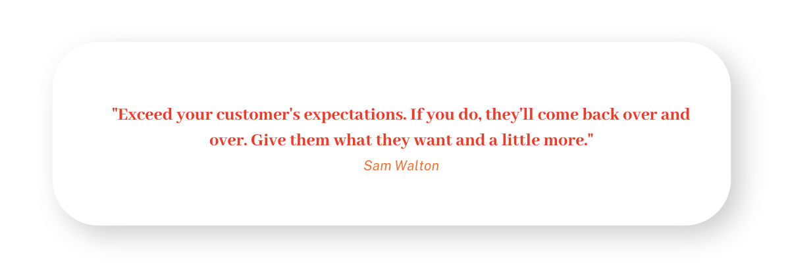

**Expectations of our Customers**

What do customers want and how do we give it to them?  
It’s not an easy question to answer. We can start by understanding that the expectations of our customers are all different.

The question for businesses is what customer expectations can we exceed that we can realistically maintain?

When insurance agencies give value to their customers and then take it away, they’re likely to disappoint. The value has to be delivered in a way that focuses on long-term goals, not short-term gain. Exceeding expectations can mean for example, exceptional service, product excellence, flexible meeting settings (e.g., over the phone, virtual meetings, in-person), personalized responses to questions & concerns, and even small things like helping a customer to their car.

It doesn’t have to mean freebies or giveaways, it’s fine if you can realistically send a magnet or a birthday card and keep it simple – just look to create value for customers elsewhere.

Investing in your employees and overhauling policies is a good starting point. Empower your team to take risks, make it okay to let them assess each customer request or complaint on its own merits to best answer questions or put a grievance right. Give them not only the authority, but the knowledge to do this well. Otherwise, you might find them overpromising and put you in a situation where you could under deliver.

Start to see your insurance agency from the outside, in from various customers perspectives.

Remember that all expectations are relative.

Some customers will demand the shirt off your back, some will pay top dollar for quality, and some will just want to walk away happy they haven’t spent their life savings.

Everyone is different.

Figure out exactly what your different customer segments expectations are before you attempt to meet and exceed them. And remember that expectations alter over time and in different contexts. You might want to consider your competitors and what they are doing, but don’t compete by offering the same thing. Innovate! Get your team on it. Ask them what they’d want if they were customers. And of course, ask your customers! Get to know them. In a world where millennials in particular feel they’re helping to co-create brands, get them on board to help you change for the better.

Geoffrey James, and the Rain Group have 10 Things Every Customer Wants based on research they conducted. According to the Rain Group customers tend to buy from individuals that are superlative at the following tasks:

1. Bringing new perspectives & new ideas – if customers could diagnose their own problems and come up with workable solutions on their own, they’d do so. The reason they’re turning to you and your agency is that they’re stuck and need your help. Therefore, you must be able to bring something new to the table.
2. Being willing to collaborate – customers absolutely do not want you to sell something, even something that’s wonderful. They want you to work with them to achieve a mutual goal by being responsive to their concerns and ways of doing business. Ideally, customers want you to become integral to their success.
3. Having confidence in your ability to achieve results – customers will not buy from you if you can’t persuade them that you, your agency, and your agency’s value prop will truly achieve the promised results. It is nearly impossible to persuade a customer to believe in these things unless you yourself believe in them. You must make your confidence contagious.
4. When you really listen to the customer – when they’re describing themselves and their needs, customers sense immediately when somebody is waiting for a break in the conversation to launch into a sales pitch, in order to really listen, you must suppress your own inner voice and forget your goals. It’s about the customer understanding all the customer’s needs
5. Understanding all the customer’s needs – it’s not enough to connect the dots between customer needs and your agency, you must also connect with the individuals who will be affected by your offering and understand how buying from you will satisfy their personal needs.
6. Helping the customer avoid potential pitfalls – Here’s where many sellers fall flat. Customers know that every business decision entails risk, but they also want your help to minimize that risk. They want to know what could go wrong and what has gone wrong in similar situations and what steps you’re taking to make sure these problems won’t occur.
7. Crafting a compelling solution – Solution selling is definitely not dead. Customers want and expect you to have the basic selling skill of defining and proposing a workable solution.
8. Communicating the purchasing process – Customers hate it when sellers dance around issues like price, discounts, availability, total cost, add on options, and so forth. They want you to be able to tell them in plan and simple language what’s involved in the purchase and how the purchase will take place. No surprises! No last minute upsells.
9. Connecting personally with the customer – ultimately, every selling situation involves making a connection between two individuals who like and trust each other. As a great sales guru once said, “all things being equal most people would rather buy from somebody they like.” And that’s true even when all things aren’t equal.
10. Providing value that is superior to other options – consider how your price compares to similar offerings unless you can prove that buying from you is the right business decision for the customer, the customer can and should buy elsewhere.

**Why Exceed Customers Expectations?**

It may seem obvious that meeting customer expectations is something that you should be doing but why should you strive to exceed customers’ expectations. What do you have to gain?  
Here are the top 10 reasons that you should be doing your best to exceed customers’ expectations.

1. It inspires feelings of gratitude from clients.
2. Encourages customers to return.
3. Customers will spend more money.
4. Creates free marketing both on and offline.
5. People will recommend you to their family and friends.
6. Complaints are less hostile because of prior service.
7. It will help minimize damage from complaints.
8. Reflects positively on the brand.
9. People believe in your brand.
10. It increases profits.

**Personalized Customer Experience**

What is personalized customer experience?

Let’s take a look! While many embrace the joys online shopping brings, the dizzy array of options, choices, add on’s and sneaky pop ups can be overwhelming.

Many companies now look to personalize the shopping experience by recommending the products customer would like to entice bigger purchases. Your buying habits are not a secret anymore.

In fact, offline they’re probably no secret either. Your favorite sales assistant has probably already signed you up for some loyalty club you’ve forgotten about it.

Think about the way you personalize for your customers. Is it just matching them to products and hoping to make a sale? Is it about scanning a loyalty card that gets lost in the dark recesses of a purse or wallet? Is it sending out an automated feedback form, knowing deep down that it’s really not going to make a difference. This is not true personalization. It must be more than that!

There’s an interesting story coming from 2009 with a Reddit user and Rogue Wallet. This customer had purchased a vegan wallet and just as the material became to come lose, the customer received a letter in the mail from the company. You might like to think about a company called Rogue Wallet who upgraded a particular line of wallets after receiving a complaint. He had not contacted them to make a complaint – instead the company had taken a pro-active approach and sent out an apology letter to all customers who had purchased this specific product.

What did Rogue Wallet do? Instead of just fixing the complain for one customer, they addressed it for all purchases of this particular wallet. They sent out the new wallets with a heartfelt and very authentic apology, which greatly impressed their customers. With this act, they protected the integrity of their brand and further insured a loyal customer base. This is true personalization!

Rogue Wallet Gets it Right

Take a look at the letter the founder, Michael Lyons sent out addressing the issue. (Cited in Ross Beard’s ‘The Complete Guide to Customer Expectations’, 2013)

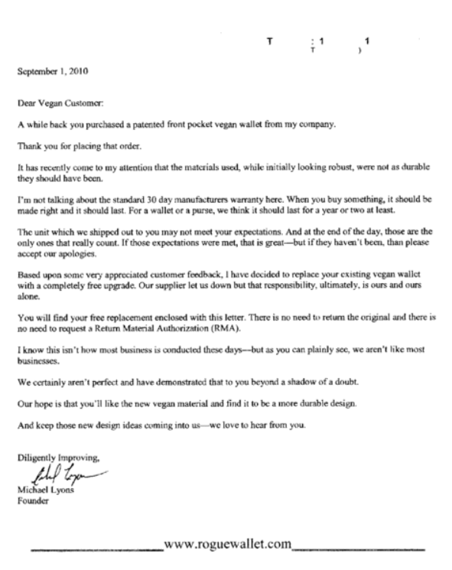

The company’s approach to service has helped them establish a positive and meaningful relationship with its customers and employees. This has gained them countless positive reviews and testimonials online for their exemplary service and treatment.

To further understand what is going on here ask yourself:

1. What feelings would arise if you were to receive service like this? Why
2. Is this kind of service a rarity or normal in your experience? Why
3. Is it difficult to meet and/or exceed customer expectations? Why or Why not?
4. As a team, make a short list of 10 ways your organization could go above and beyond to personalize service and make emotional connections with consumers. Keep them simple and easy to do, for example, a smile and friendly greeting.

Think through the ways businesses personalize their customers’ experiences. Don’t think about how they match their customers with products or give them a loyalty card to scan. True personalization is more than that. Look at these real social media interactions between companies and their clients!  
*(We’ve removed the clients’ names to protect their privacy.)*

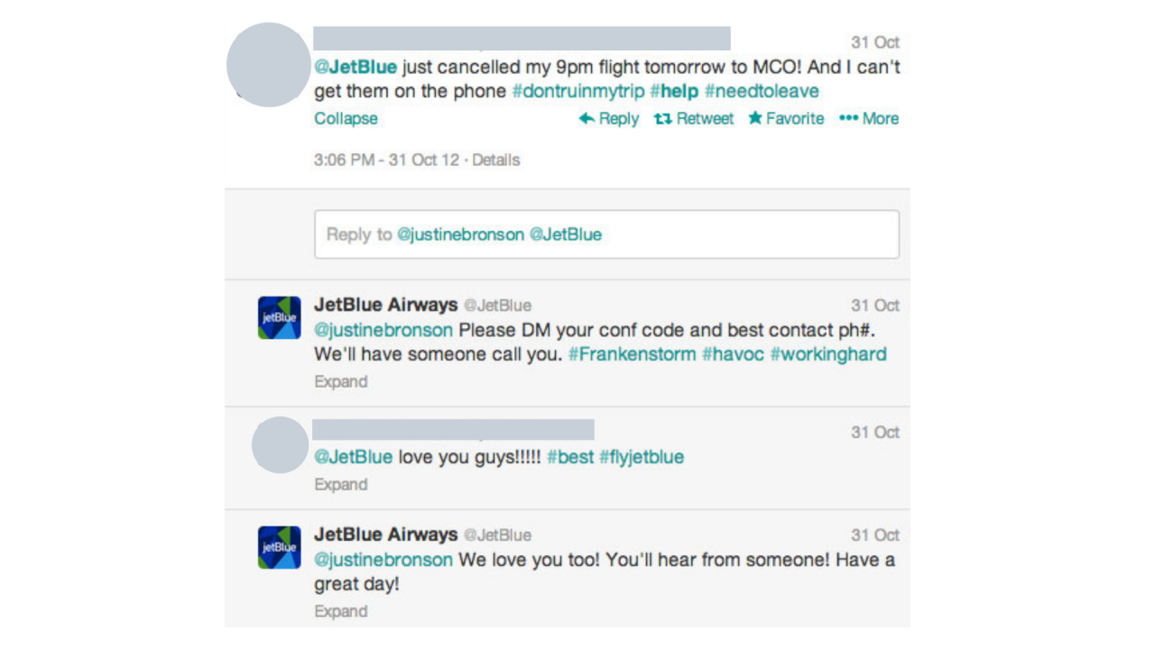

There’s a lot to gain by studying these interactions. Consider:

1. What makes them personal? Why?
2. Is this an effective way to generate customer loyalty? Why?
3. Evaluate the degree to which these examples improve brand perception.

**Buying Habits of a Contemporary Customer**

In the digital era, shopping has changed, let’s consider the buying habits of contemporary customers and in particular millennials, as contemporary customers, we are becoming very discerning.  
Modern shoppers look to online sources to verify purchases. They will often consult a device before going into a store about the affordability, suitability, and expected longevity of a product.

Even when in store, it would not be unusual for a modern shopper to be comparing prices and value for money on a smartphone, and they’ll often share information about products and services on social media.

Millennials are quite savvy when it comes to making choices, and the opinion of peers and friends are important in buying decisions. What was once a pool of people relied upon for advice, has literally exploded with the arrival of the internet and social media. Pop culture trends enter as quickly as the old ones exit. It’s like a revolving door; nothing stays “cool” for long. Remember, we’re selling to the most socially diverse generation ever.

Millennials expectations as customers have been shaped by the generation’s lifetime immersion in the fast-evolving world of online commerce, search engines, and on the go connectivity. These are customers who’ve likely never waited in line at the bank, who’ve rarely waited for letters to arrived by mail, who’ve seldom had their music choices limited to what’s on the radio or a mass market CD. They have grown up in a time when its possible to align their shopping with their values. The options of humane, green, fair trade, organic, employee-owned and so forth. Or not.

Millennials are the sociable generation and millennials, this is sociability is expressed online as well as in real life, particularly in the arenas where online and offline activities and circles of friends overlap.

A shopping habit that sets millennials apart from non are their tendency to shop in groups and seek the opinions of others. More than 2 3rd of millennials don’t make a major decision until they’re discussed with a few people they trust.

Millennials can be vital carriers of a business’s message to not just heir friend, but their parents. That’s why even if you’re marketing to another generation, it’s incredibly impactful to find an offering and a space for the millenial customer segment.

They also enjoy the possibility of collaborating with businesses & brands as long as they believe what they’re saying matters to the company in question. They don’t necessarily see a clear boundary between the customer and the brand.

Alex Castellano at Dropbox, put it this way: “With millennials, a new brand service or product is only started by the company. It’s finished by the customers. Millennials are a generation that wants to co-create the product, the brand with you. Companies that understand this and figure out ways to engage in this cocreator relationship with millennials will have an edge.”

Millenials are looking for an experience – it’s a dangerous mistake to think of the millenial generation as hard edge technocrats; on the contrary – they crave personal experiences.

Jennifer Fox, President of Fairmont Hotels & Resorts agrees – “Younger customers coming into the marketplace hope and desire that we will deliver an emotional narrative that resonates with them.”

Is your organization speaking to them in their language?

**The Link Between Decision Making & Emotions**

Let’s take a look at the link between decision making and emotions. David Brooks in The Social Animal discusses that we are not strictly logical beings, and will often, if not always, be influenced by our feelings when making decisions, including what to buy and where to buy from. He says, reason and emotion are not separate and opposed, reason is nestled upon emotion and dependent upon it. Emotion assigns value to things, and reason can only make choices based on those valuations. Bruce Jones makes these points on why emotional connections are the key to exceptional customer service, “The Gallup Organization states that if you do not make an emotional connection with customers then satisfaction is worthless.” This research proves that customers do not buy strictly for rational reasons, it’s more important to engage customers on an emotional level.

Additional research suggests that organizations that optimize this emotional connection outperform competitors by 26% in gross margin and 85% in sales growth.

In fact, emotionally engaged customers are at least 3x more likely to recommend, 3x more likely to repurchase, and less likely to shop around, and much less price sensitive.

Positive emotional connections will ultimately drive the length and frequency of that customers engagement with your organization. It’s why we believe the power of service lies in its ability to create an emotional connection rather than a purely rational connection. Consider the emotions your organization is evoking in these customers. Will these emotions inspire a long-term relationship?

It’s funny to think of your customers as potential romances, but for a moment – compare it to a romantic relationship. Do you want a brief interclude, a casual thing, or a something long-term and meaningful?

Of course, you’re probably going to aim for the latter. So consider ways to make this happen, after the wooing, dating, and something more serious has started – you need to put in some work to keep the spark alive!

And if there’s real emotion there, the spark is more likely to burn longer.

What’s your game plan?

Consider these scenarios. How would you make an attempt to re-engage each of these customers? Think about things like personalization, understanding modern shopping habits and engaging customers’ emotion when responding.

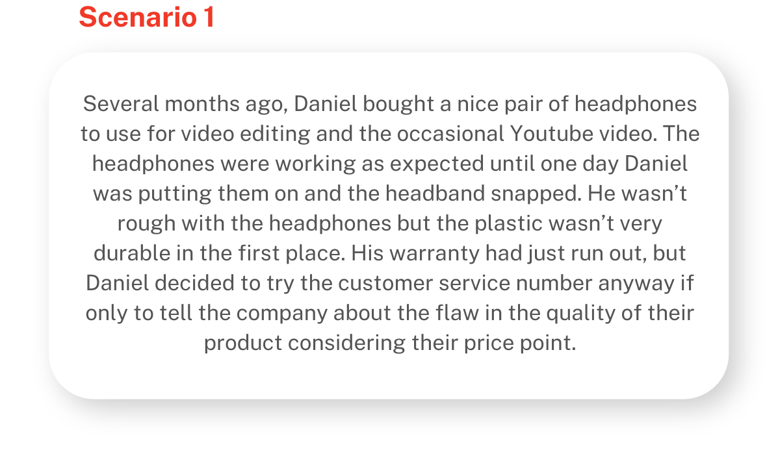

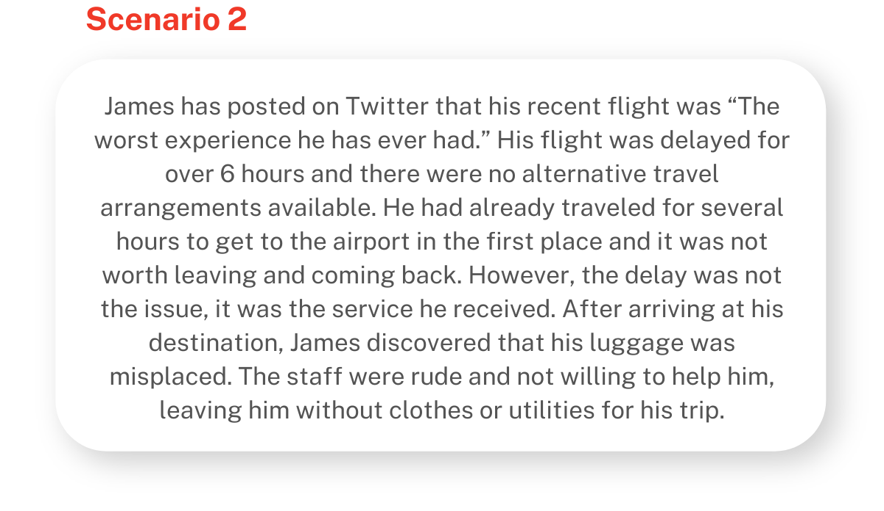

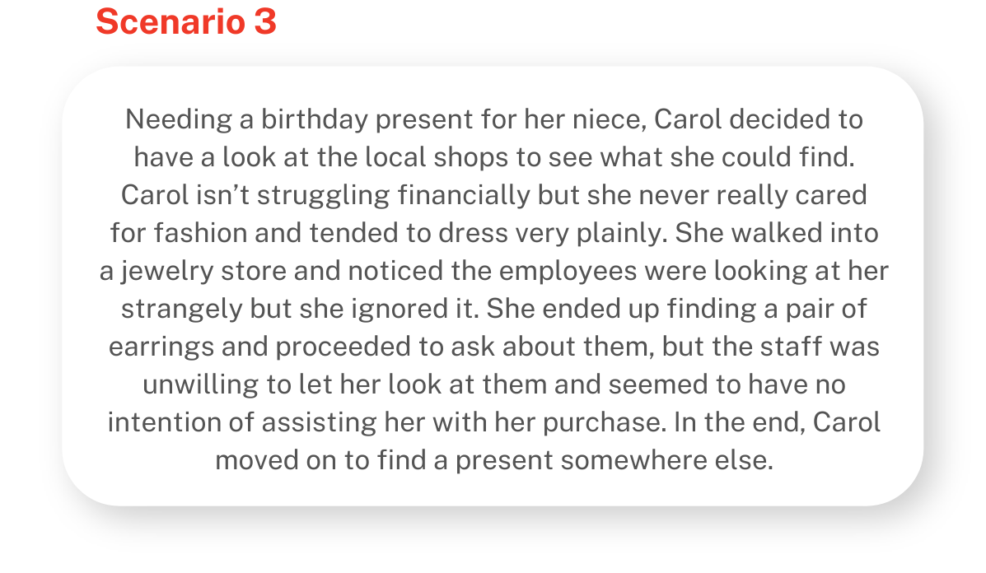

Where to go from here?

I’m loving the dedication you now know more about what drives your customer needs and have some strategies to help you meet them! If you’d like to continue your customer exploration, join us as we take you through how to manage customer feedback and really challenge yourself and join the entire customer at your service course.