1 General Information

1.1 Supported Browsers
- Compatibility for Miramar-Agent is tested with the following browsers: Firefox, Chrome, IE9+, Edge.
- Please make sure you have your pop-up blockers turned off before starting certification

1.2 Register as an Agent
- All users will use the same website address (URL) to access the site: https://miramar-agent.com
- Do not register with agency information! Once registered as an individual you will have the opportunity to indicate you are the principal of an agency.
- First-time users should self-register by clicking on “Register as an Agent”.
  - Usernames and Passwords are self-assigned during registration.
- Logins are NOT carrier/plan or program specific. Returning users will use their existing Username and Password to access any additional programs they need to complete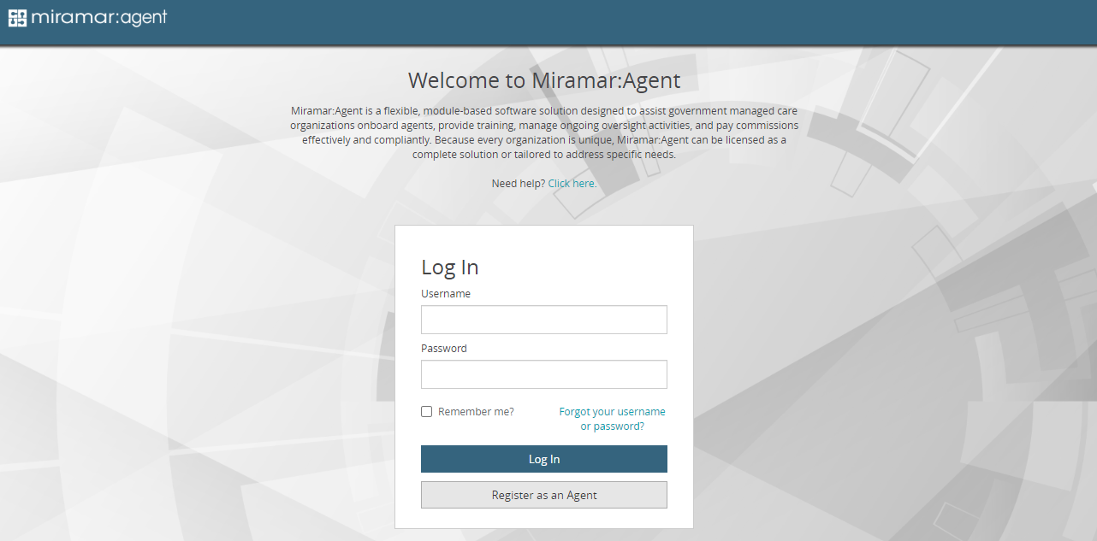
- The first step of registration is entry of Social Security Number (SSN).
  - SSN is the unique identifier for users in the system. This step will check all existing users to verify the SSN entered does not already exist in a profile.
  - Failure to use a valid SSN could result in the inability to successfully complete a program, as SSN is used for certain actions, such as background checks.
  - Agents who were given a Registration Code by their carrier or upline will enter the code immediately following the SSN validation.
- All required fields are indicated on the registration form with an asterisk (*).
- Username and password is self-assigned by each user on the form. Passwords must contain the following:
- Minimum of 8 characters, 1 uppercase letter, 1 lowercase letter, 1 number, and 1 special character.
- Once all fields have been completed, clicking “Complete Registration” will prompt the user to login with their credentials.

2 Agent Dashboard
- The Agent Dashboard is the hub of Miramar-Agent, it provides a snapshot of your activity in the system.
- On your dashboard, you will see widgets for the following current information:
  - Active Programs
  - Ready to Sell (current and future benefit years)
  - Groups (current)
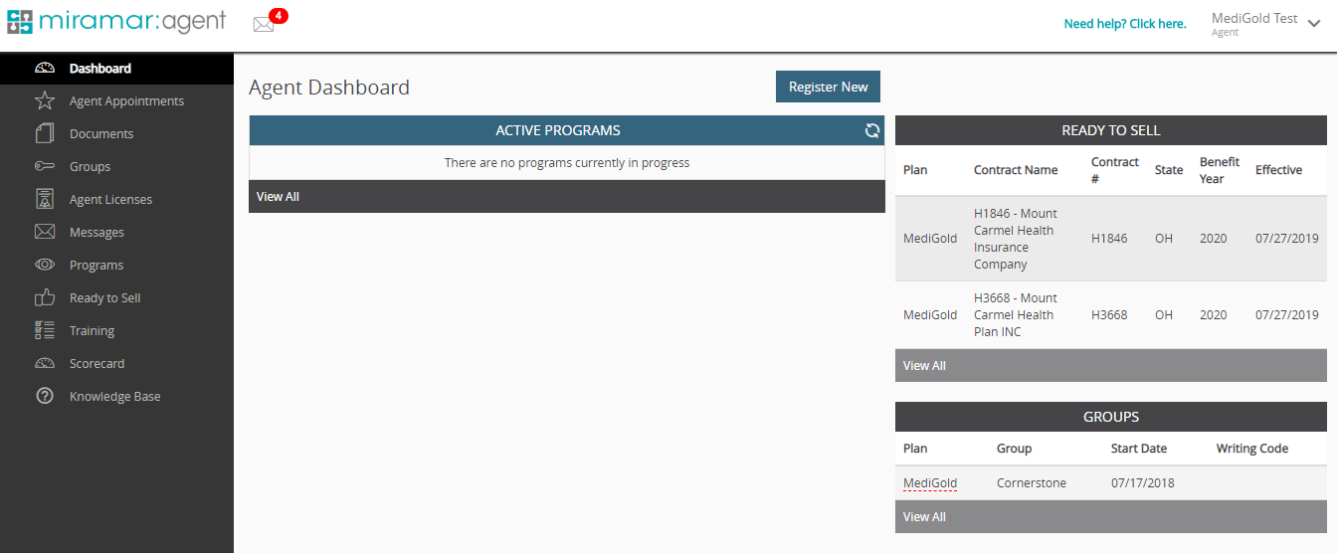

3 Register for the 2025 Medigold program
- Click on "Register New" in the Agent Dashboard
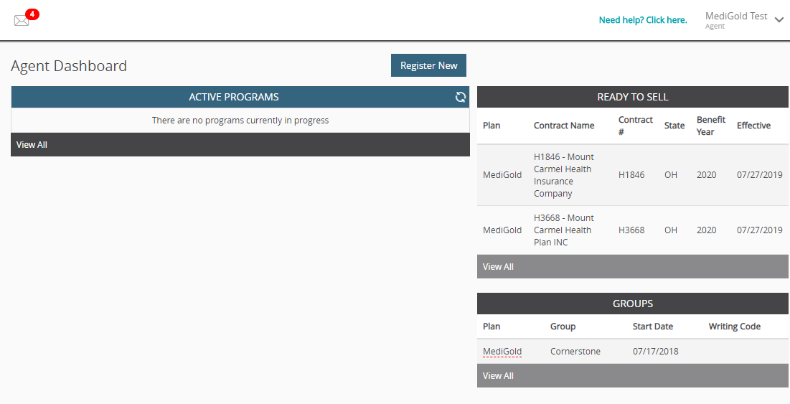

- Enter the registration code that is provided to you by your FMO and click submit
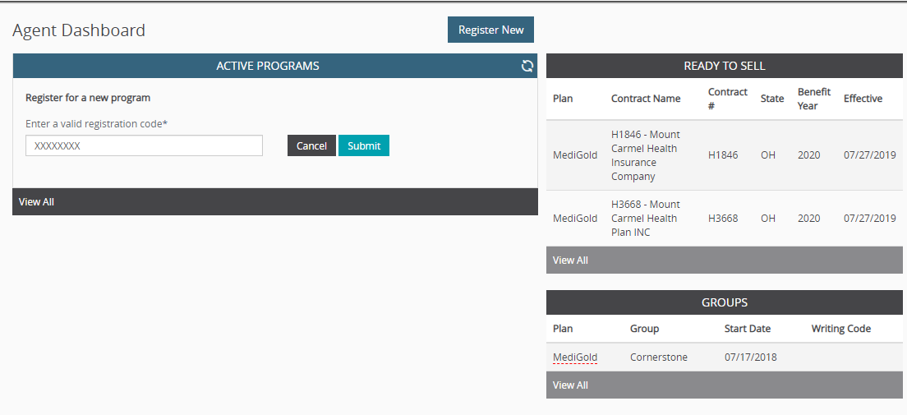

- Click on "Start" to kick off your 2025 program
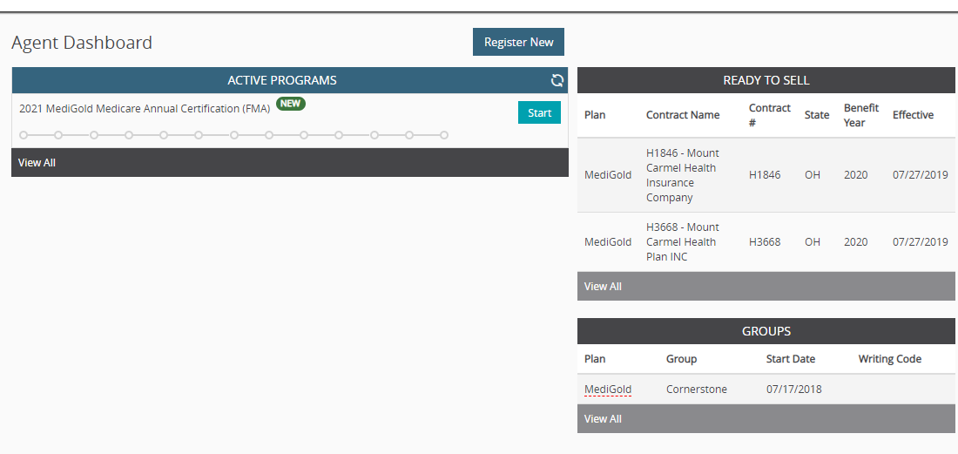

- Click on "OK"

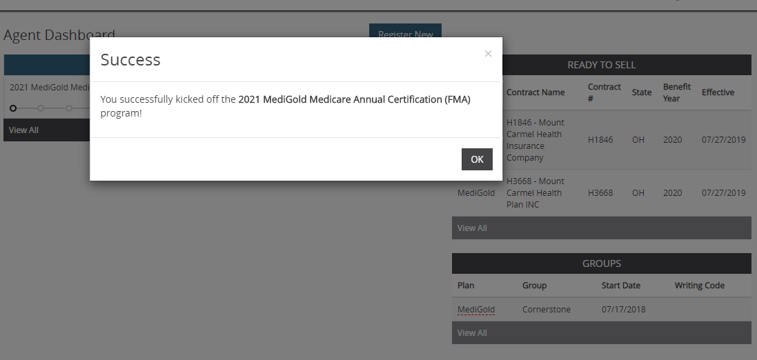

- Click on "Welcome"

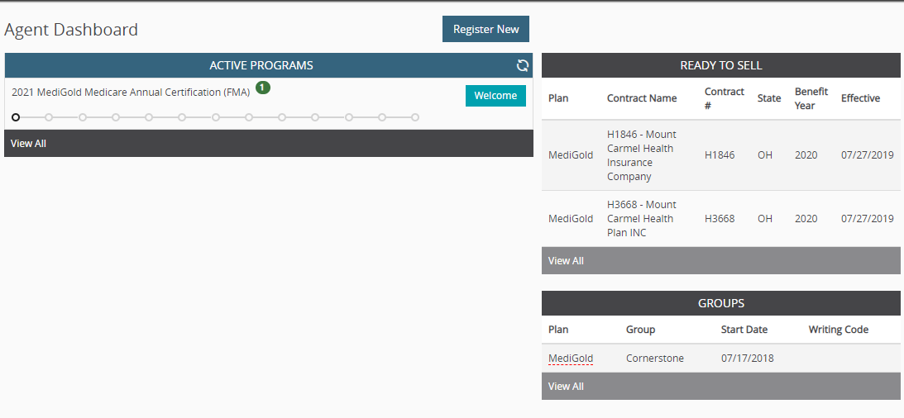

- A pop up will come on your screen and Welcome you to Miramar-Agent. Once you read, click on "Continue"
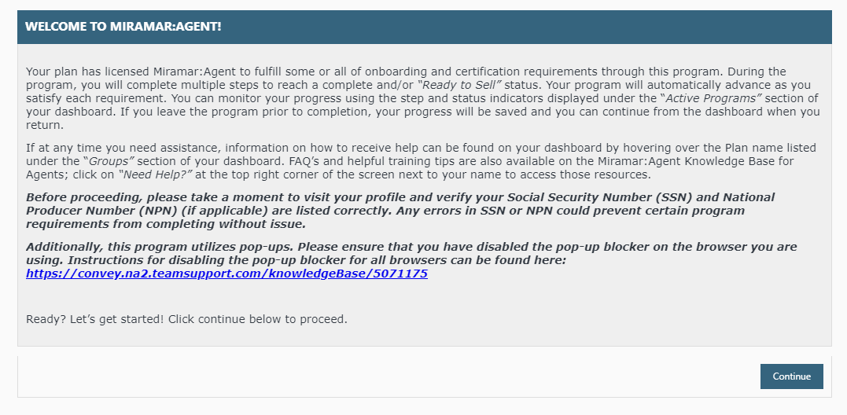

- The MediGold Code of Conduct will now appear, if you agree, select the box and click on "Continue"
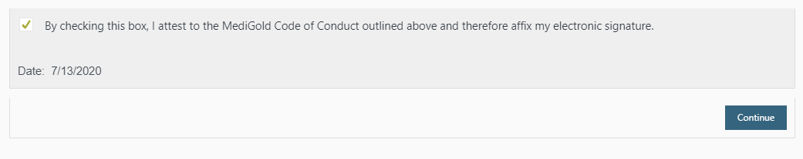

- The MediGold Background Attestation will appear. Please answer the questions truthfully. If "Yes" is answered to any of the questions, please submit detailed response to MediGoldBrokerSupport@mchs.com

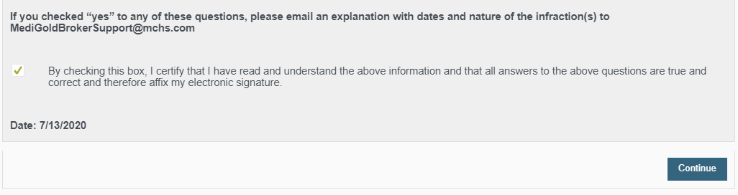

- The MediGold background check consent will now appear. Please type read, type in your name and select "Accept"

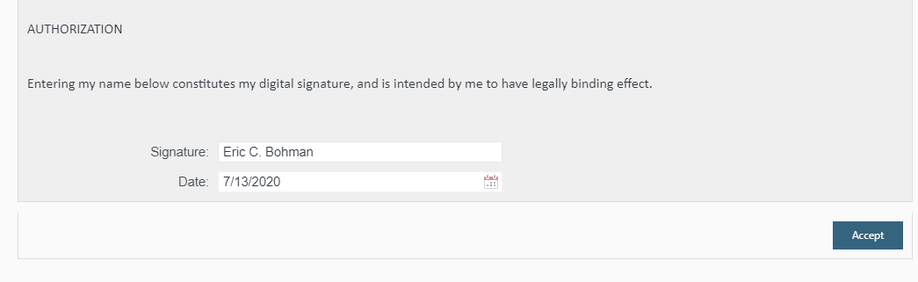

- The MediGold Agent Contract and E&O attestation will now appear. Please check box and select continue
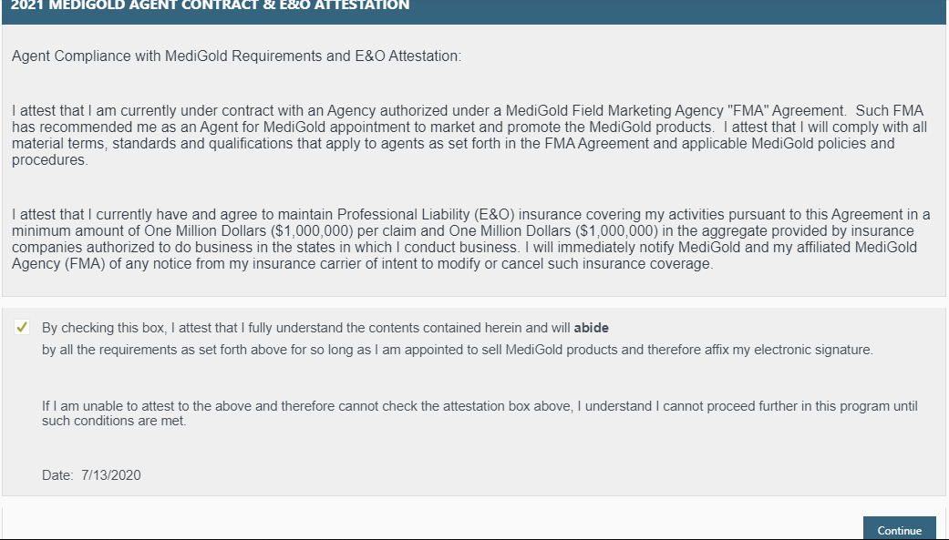

- You now need to upload your AHIP certificate. Please follow the screenshots below:
- To upload a document:
- Click “Yes” under “Do you want to upload a certificate?”
- Click the box next to “Attach File”
- Locate the file on your computer and select it
- Click “Submit”
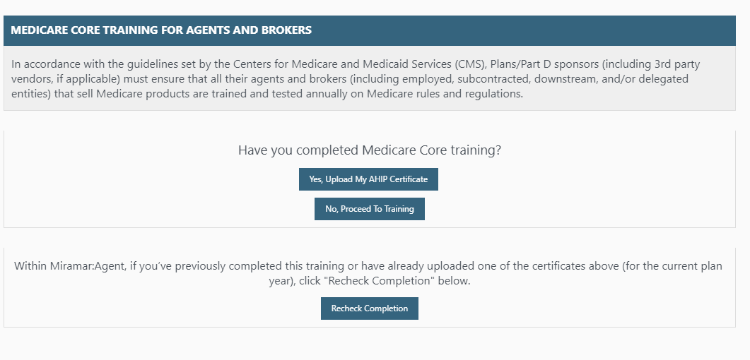
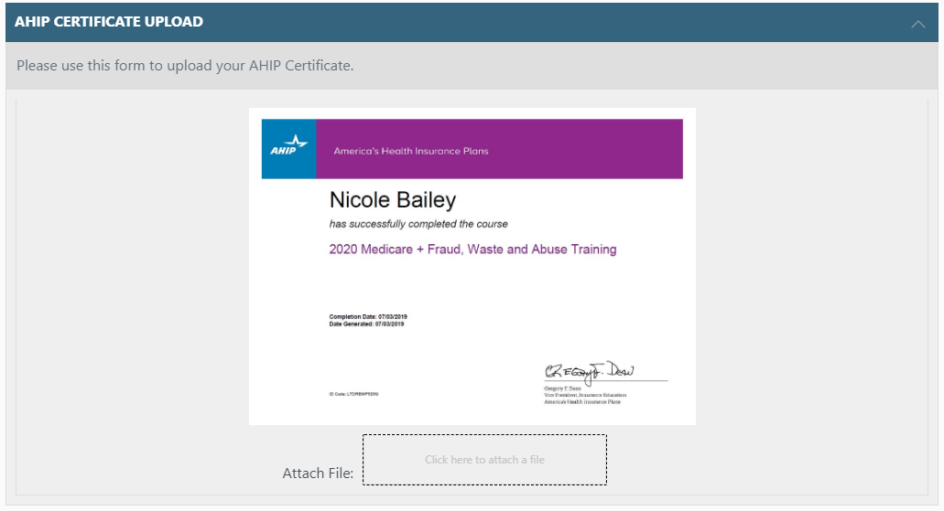

- If your certificate was uploaded successfully, you will receive the notice below:
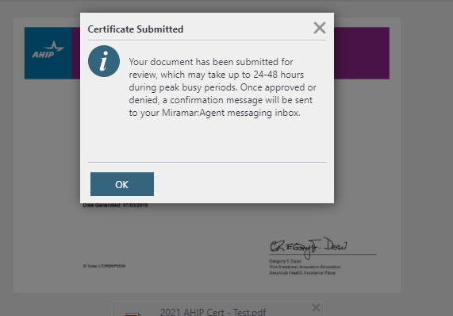

- You will now be directed towards the MediGold Non-Compliance and FWA information. If you agree, select "Continue"
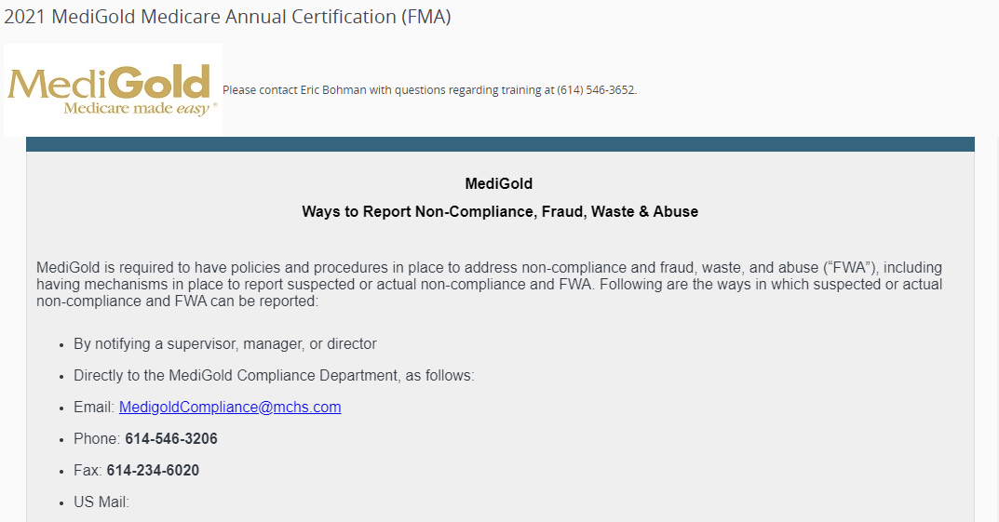

- You will now be directed to the Assignment of commissions. You can select "Pay me Directly" or you can select "Pay my Upline". If you are looking to have commissions assigned to your upline, please select "Pay my Upline"
  - If you select "Pay me Directly" you will be able to complete an ACH Authorization and a W-9.
  - If you select "Pay my Upline" you will be directed to complete information to have the payment directed towards the agency. Also a W-9 will follow. Make sure you are attaching your Upline’s W9, not your independent agency or individual W9.
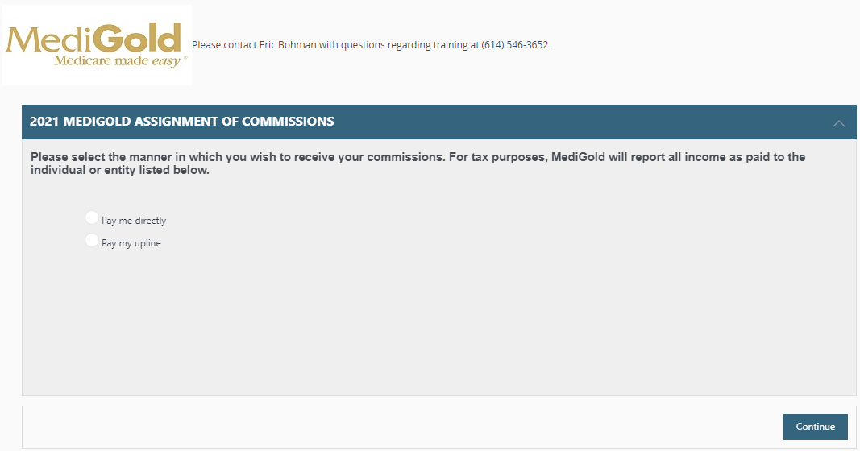

- You will now be directed to choose the state or states you will be selling in. Once selected, please click on continue
  - Please note: If you do not have a license to sell in the state you select, please do hit continue. This will hold up your appointment with MediGold

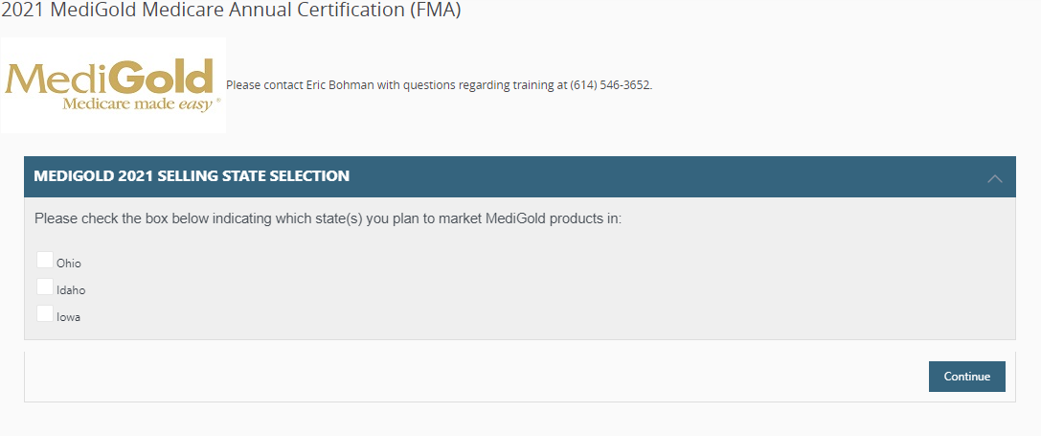
- You will now be directed to the 2025 Product Training. Select the green arrow to launch your product training
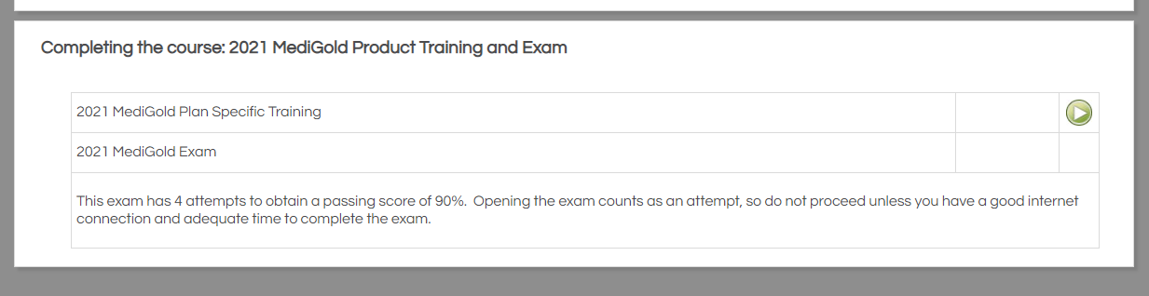

- Once you have gone through the slides, please select close on the top right

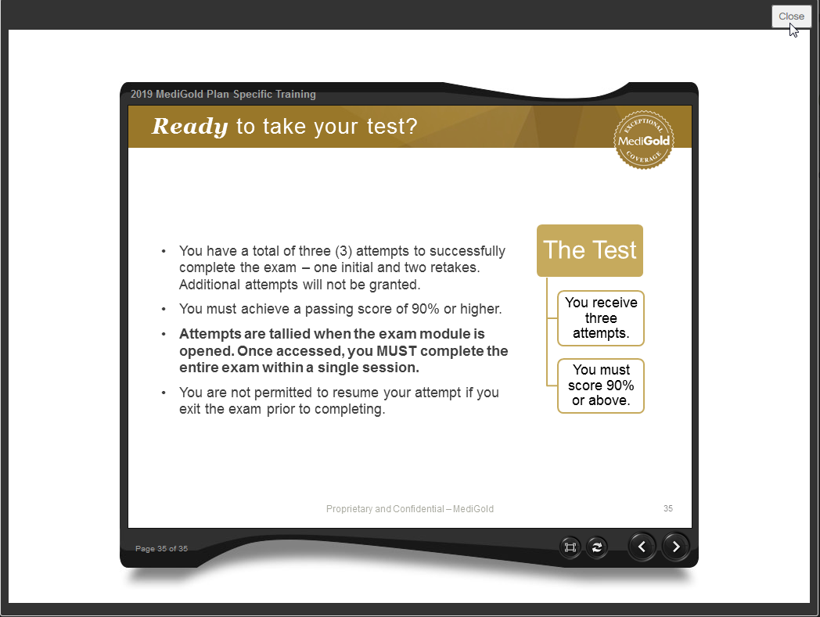

- To take the exam, select the green arrow in the row where it states, "2025 MediGold Product Training"

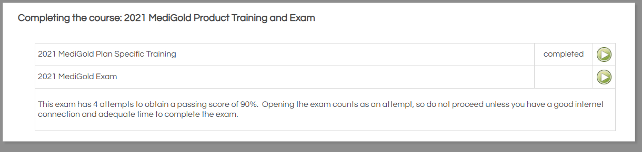

- Once you have completed and passed your 2025 MediGold Product Training, please select "Close" on the top right
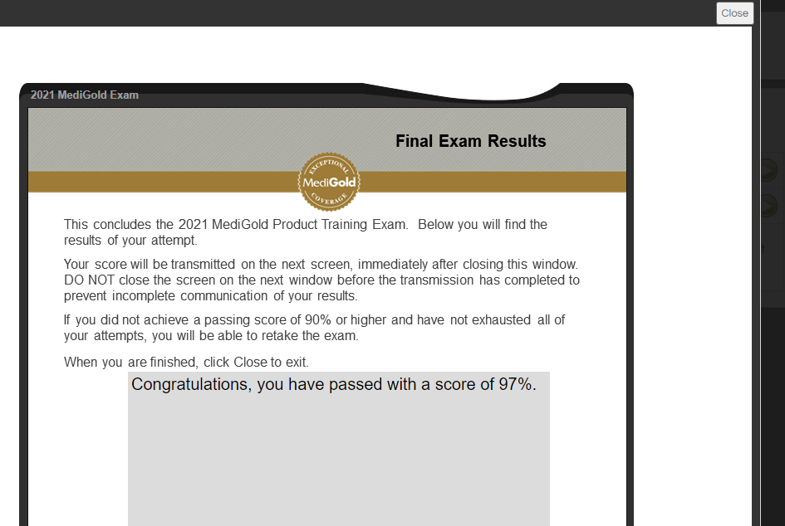

- Follow the directions and close the current tab you are in

- Click on your "Agent Dashboard on the left hand side of your screen
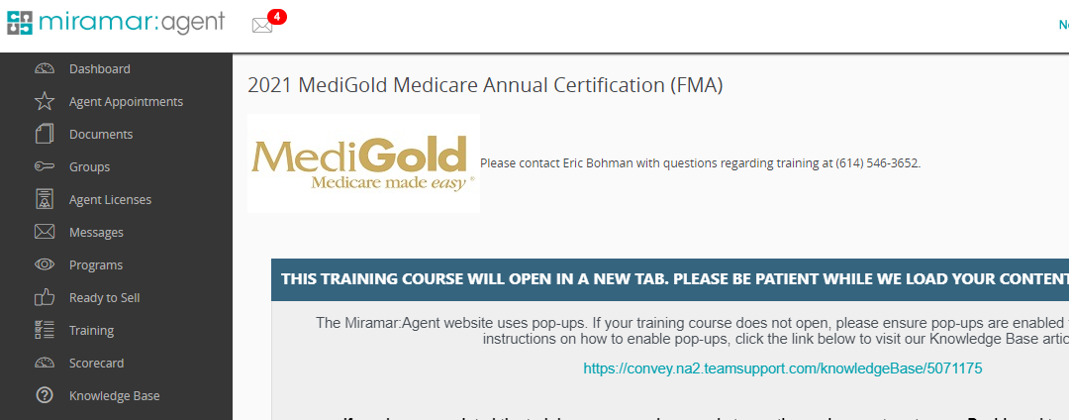

- Select "Next Steps"

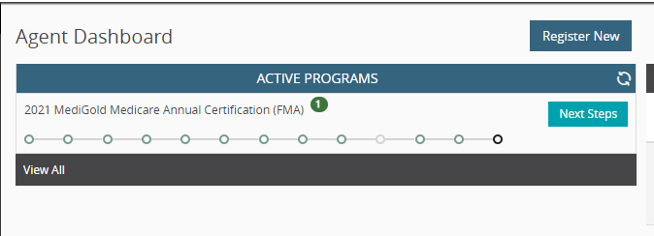

- You have now completed your 2025 MediGold Product Training. Select "Continue"

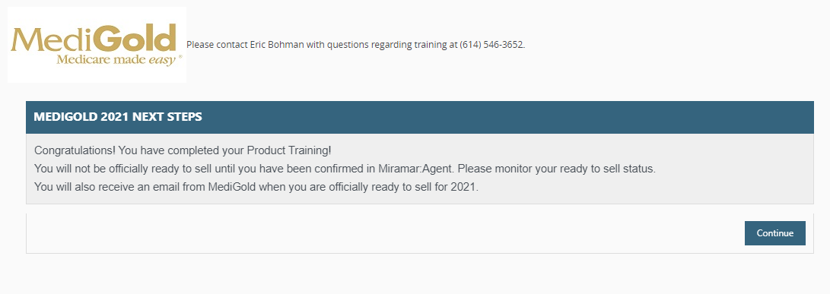

- PLEASE NOTE: Once the product training has completed, your appointments will be submitted to the state. You will be able to monitor your "Ready to Sell" status on your agent Dashboard. You will also receive an email once you have been marked "Ready to Sell"

