How to Order Medicare Materials

PURPOSE: This job aid will show you how to order materials for PY2025.

Click the Agent Order Link | The order system will open for 2025 material ordering July 12th for New Certs and Recertifications. Place order by 8/16 to receive materials by 9/30  https://printandfulfillment.adp.com/HumanaDelegatedAgents/Forms/UniversalLogin.aspx
Login  Step 1  Step 2  Step 3 | 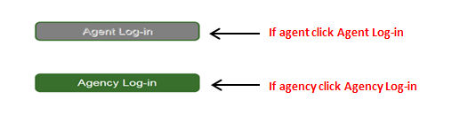  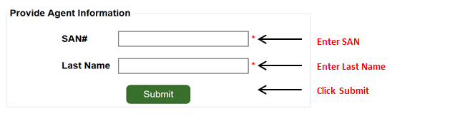
Choose your Plan Year | 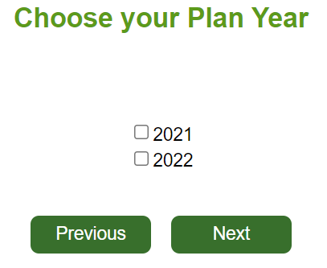  Select plan year  Click Next  2024  2025
Add Contact Information
Choose your State and County
Choose your Materials - Plans | Choose your plan  Click Next
Choose your Quantity | 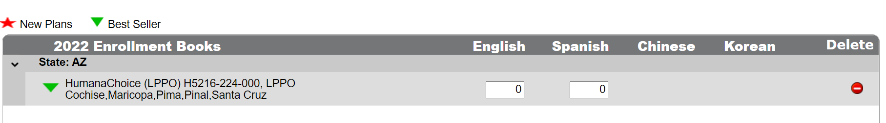  Click Next  Enter quantities:  Chinese and Korean boxes will only display if the plan is translated
Choose your Materials -Individual items  NOTE: Individual items may be applications, etc. | 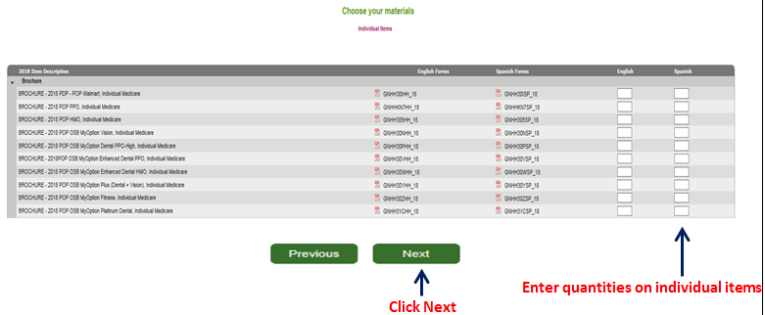
Choose your Materials – Medicare Supplement Items | 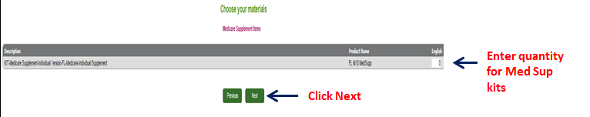
Review Order Summary | 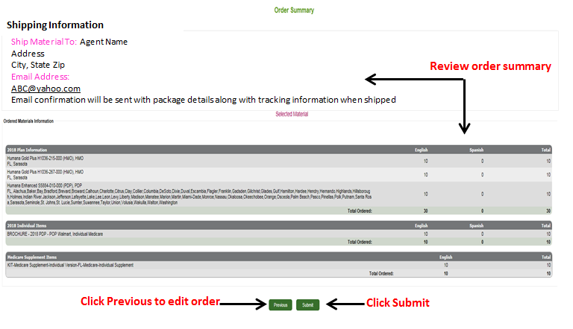
Confirmations | After you submit your order, you get 3 notifications:  - Immediately following your order, you will see the Order Confirmation screen letting you know that you have successfully completed your order  - You will receive an order confirmation e-mail after your order is submitted. The e-mail will go to the e-mail address provided in this order.  - Once your order has shipped, you will receive a shipping confirmation e-mail to the e-mail address provided on this order. You will be able to click on the order tracking link to track your order, once it’s shipped.
How to track you order | How to track an order job aid
How to copy and existing order | How to copy an order job aid
How to create a profile | How to create a profile job aid

