Get Certified for 2025 with Alignment Health Plan - Exciting Updates Inside!
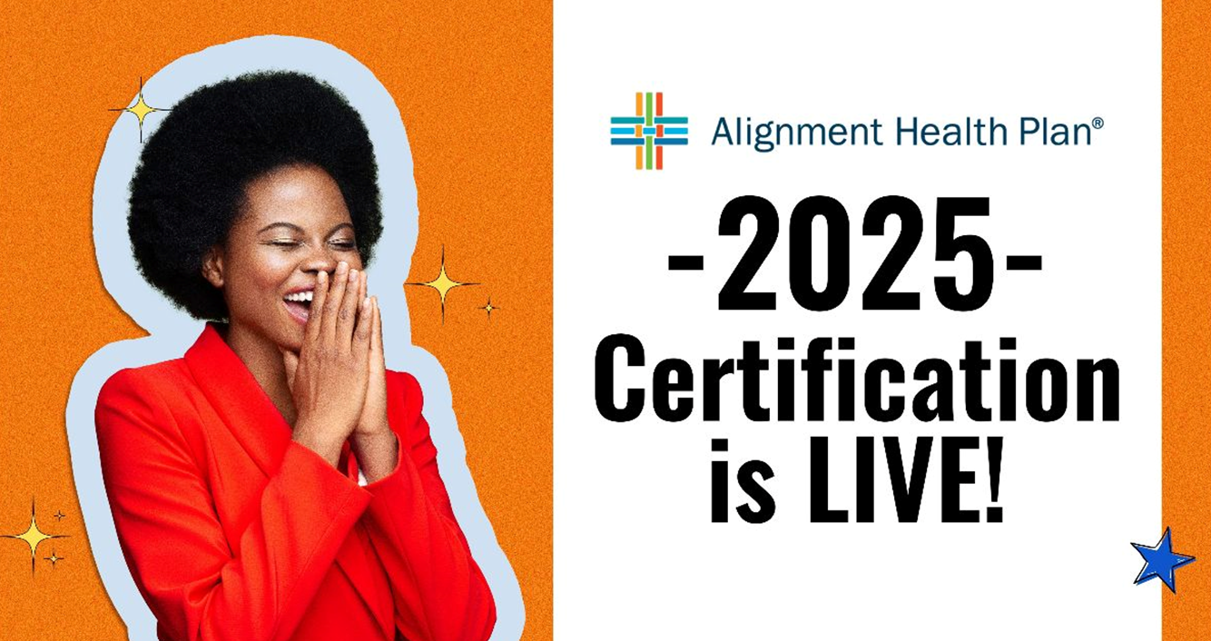
Are you a new agent, or a returning agent? It's time to get certified and unlock your potential with Alignment Health Plan! 🚀
Follow These Simple Steps to Certification:
For Returning Agents:
- Access your recertification by logging into the Alignment's agent portal: agents.alignmenthealthcare.com
- Click the Certification tab.
- Follow the instructions and finish the certification training & exam.
For New Agents:
- Go to www.AlignmentHealthPlan.com and click on the FOR AGENTS tab.
- Click on "Need to certify or recertify?"
- Input your NPN number and follow the instructions.
- You have three attempts to pass with a minimum score of 85%, so plan for some uninterrupted time to ace it! 🏆
Remember, certification is essential to continue receiving renewals. Ensure you complete your annual certification by 12/31/2024.
What's New for 2025?
- E&O Insurance:
  - You will now attest that you have and will maintain an E&O policy as required by your contract with Alignment Health. Upon request, you will need to provide it.
- AHIP: Discounted Training Cost:
  - Alignment Health Plan agents can now enjoy a discounted rate for AHIP training. Instead of the usual $175, you can complete your AHIP training for only $125!
  - By associating your AHIP profile with Alignment Health Plan, you can experience a faster and more efficient certification and onboarding process. No more manual uploading of your AHIP certification—everything will be seamlessly integrated for a smoother experience.
  - To take advantage of these benefits, please follow the link below to start your AHIP training and associate your profile with Alignment Health Plan:
AHIP Training - Alignment Healthcare
- Licenses:
  - We've integrated with NIPR, which will allow us to identify all your licenses easily.
All these enhancements were made with your feedback in mind. This will allow you to stay up-to-date with Alignment Health seamlessly.

